**HCMC UNIVERSITY OF TECHNOLOGY AND EDUCATION**

**FACULTY OF HIGH-QUALITY TRAINING**



**TOPIC:**

**WATER LEVEL CONTROL USING FUZZY LOGIC AND NEURAL NETWORK SYSTEM**

**Major: Intelligent Control  
Lecturer: Nguyen Minh Tam**

**Group members:**

**Le Thanh Nam – 17142122**

**Nguyen Tan Loc - 17151017**

**TRƯỜNG ĐẠI HỌC SƯ PHẠM KỸ THUẬT THÀNH PHỐ HỒ CHÍ MINH**

**CỘNG HOÀ XÃ HỘI CHỦ NGHĨA VIỆT NAM**

**Độc lập - Tự do - Hạnh Phúc**

**KHOA ĐÀO TẠO CHẤT LƯỢNG CAO**

**BẢNG NHẬN XÉT CỦA GIÁO VIÊN HƯỚNG DẪN**

Sinh viên: **LÊ THÀNH NAM**

MSSV: 17142122

Khoa: Đào tạo chất lượng cao

Ngành: Điều khiển và tự động hóa

Tên đề tài: **Water level control using fuzzy logic and neural network system**

Sinh viên: **Nguyễn Tấn Lộc**

MSSV: 17151017

Khoa: Đào tạo chất lượng cao

Ngành: Điều khiển và tự động hóa

Tên đề tài: **Water level control using fuzzy logic and neural network system**

TP. HCM, ngày… tháng… năm 2022

Giáo viên hướng dẫn (Ký & ghi rõ họ tên)

Contents

**ABSTRACT** 4

**CHAPTER I** 5

**INTRODUCTION** 6

**I.** **Problem Statement** 6

**II.** **Project Objectives** 7

**III.** **Project Scopes** 8

**CHAPTER II** 9

**BACKGROUND** 10

**I.** **Intelligent Control Method** 10

**a.** **Definition of Fuzzy Logic Control** 10

**b.** **Definition of Neural Network System** 10

II. **Type of Fuzzy Logic Systems** 11

**III.** **Forward/Backward Propagation.** 12

**CHAPTER III** 14

**STIMULATION** 15

**I.** **Fuzzy Logic System** 15

1. **Fuzzy Logic Control** 15

2. **Matlab Simulink** 18

**II.** **Neural Network System** 20

**1.** **Building A Neural Network System** 20

2. **Matlab Simulink** 25

**CHAPTER IV** 26

**CONCLUSION** 27

**I.** **Conclusion** 27

**References** 28

# **ABSTRACT**

Water level control is highly popular in industrial applications. The paper presents a study on the design of an intelligent controller for a water tank level control system using fuzzy logic and neural network systems. The proposed system is designed to control the water level in a tank by adjusting the flow rate of the inlet and outlet valves. The water level control system is separately simulated on Matlab Simulink in order to compare the speed, the precise of the two systems. Consequently, the results show that the system is able to control the water level in the tank efficiently. The proposed system is expected to be useful in various applications, such as water treatment plants, industrial processes, and nuclear power plants.

# 

# **CHAPTER I**

# **INTRODUCTION**

1. **Problem Statement**

[1]The major goal of this study is to adjust the liquid level in a tank; the overall system construction is represented in Fig.1. A water tank and a pump powered by a 12V direct current motor comprise the system.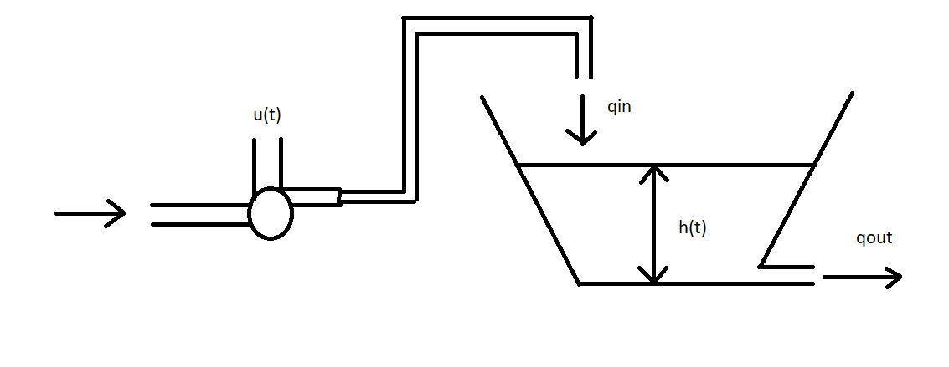

**Figure 1: Single water tank system**

As shown in Figure 1[2], the cross-section of the water tank system varies with height, and the differential equation defining the system is:

Where:



|  |  |  |
| --- | --- | --- |
| **SYMBOLS** | **DEFINITIONS** | **UNITS** |
| u(t) | The voltage controls the pump (0≤u(t)≤12V) | V |
| h(t) | The height of the water level | cm |
| A(h) | The cross-section of the tank | cm2 |
| hmax | The maximum height of the tank | cm |
| Amax, Amin | The maximum and minimum of the section | cm2 |
| k | The factor proportional to pump power | cm3/s |
| α | exhaust valve cross-section | cm2 |
| g | gravity acceleration | cm/sec2 |
| CD | discharge coefficient | constant |

**System parameters:**

[2]The parameters of the single water tank system are chosen as follows:

hmax= 50 cm;

Amax= 400 cm2;

Amin= 100 cm2;

α= 1 cm2;

k = 300 cm3/sec;

CD= 0.6;

g= 981 cm/sec2.

1. **Project Objectives**

The major goal was to create a fuzzy logic and a neural network system that could manage the tank's water level. Once we've specified the necessary settings, the fuzzy logic system will compute the water tank system's input. The tank's water level may then be adjusted.

1. **Project Scopes**

The fuzzy logic and neural network are only tested in Matlab Simulink and still not build the real protocol.

# **CHAPTER II**

# **BACKGROUND**

1. **Intelligent Control Method**
   1. **Definition of Fuzzy Logic Control**

[1] The fundamental concept of Fuzzy Logic is the membership function, which defines the degree of membership of an input value to a certain set or category. The membership function is a mapping from an input value to a membership degree between 0 and 1, where 0 represents non-membership and 1 represents full membership.

Fuzzy Logic is implemented using Fuzzy Rules, which are if-then statements that express the relationship between input variables and output variables in a fuzzy way. The output of a Fuzzy Logic system is a fuzzy set, which is a set of membership degrees for each possible output value [1].

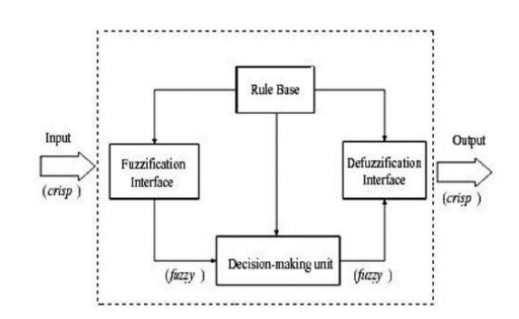

**Figure 2.1: Fuzzy Logic Control**

* 1. **Definition of Neural Network System**

Neural networks, also known as artificial neural networks (ANNs) or simulated neural networks (SNNs), are a subset of machine learning and are at the heart of deep learning algorithms. Their name and structure are inspired by the human brain, mimicking the way that biological neurons signal to one another.

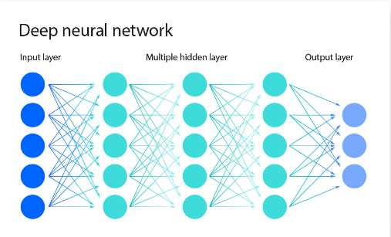Artificial neural network (ANNs) are comprised of a node layers, containing an input layer, one or more hidden layers, and an output layer. Each node, or artificial neuron, connects to another and has an associated weight and threshold. If the output of any individual node is above the specified threshold value, that node is activated, sending data to the next layer of the network. Otherwise, no data is passed along to the next layer of the network. [2].

**Figure 2.2: Neural network**

1. **Type of Fuzzy Logic Systems**

[3] There are two major types of control rules in fuzzy control:

* + 1. Mamdani System – This method is widely accepted for capturing expert knowledge. It allows us to describe the expertise in more intuitive, more human-live manner. However, Mamdani-type FIS entails a substantial computational burden.
    2. Takagi – Sugeno – This methos is computationally efficient and works well with optimization and adaptive techniques, which makes it very attractive in control problems, particularly for dynamic non-linear systems. These adaptive techniques can be used to customize the membership functions so that fuzzy system best models the data.

In this paper, the Mamdani system is the major method that will be used in the fuzzy logic system.

1. **Forward/Backward Propagation.**

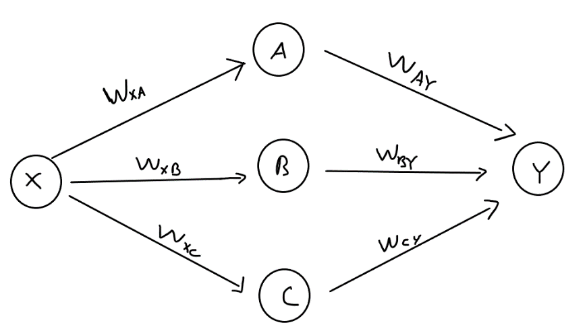Assume we have a network with one input, three layers, and one output.

[4]The forward propagation is the process of computing and storing intermediate variables (including the output) of a neural network in order from the input layer to the output layer, and it has the following steps to compute:

* Step 1: Calculate variables A, B, and C

$$A=X*W_{XA}$$

$$B=X*W_{XB}$$

$$C=X* W_{\begin{aligned}XC \\ \end{aligned}}$$

$Step 2:Calculate the output$

$$Y=A*W_{AY}+B*W_{BY}+C*W_{CY}$$

Backpropagationrefers to the method of calculating the gradient of neural network parameters. In short, the method traverses the network in reverse order*,* from the output to the input layer, according to the chain rule from calculus. Backpropagation can be computed by following steps:

* Step 1: Calculate the errors of output layers
$${Error}_{Y}=Y*(1-Y)(Y_{target}-Y)$$

* Step 2: Calculate the bias of hidden layers
$$w_{AY+}= W_{AY}+η*{Error}_{Y}*A$$

$$w_{BY+}= W_{BY}+η*{Error}_{Y}*B$$

$$w_{CY+}= W_{CY}+η*{Error}_{Y}*C$$

* Step 3: Calculate the error of hidden layers:
$${Error}_{A}=A*(1-A)({Error}_{Y}*w_{AY+})$$

$${Error}_{B}=B*\left(1-B\right)\left({Error}_{Y}*w_{BY+}\right)$$

$${Error}_{C}=C*(1-C)({Error}_{Y}*w_{CY+})$$

* Step 4: Calculate the bias of input layers

$$w_{XA+}= W_{XA}+η*{Error}_{A}*X$$

$$w_{XB+}= W_{XB}+η*{Error}_{B}*X$$

$$w_{XC+}= W_{XC}+η*{Error}_{C}*X$$

# **CHAPTER III**

# **STIMULATION**

1. **Fuzzy Logic System**
2. **Fuzzy Logic Control**

The fuzzy logic system is designed to compute $K_{p}$ and $K_{i}$ in order to control the input voltage to the designed water tank.

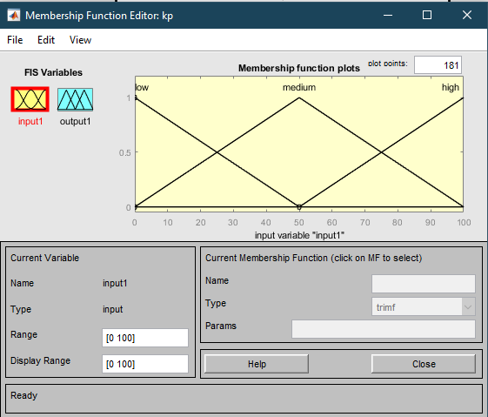

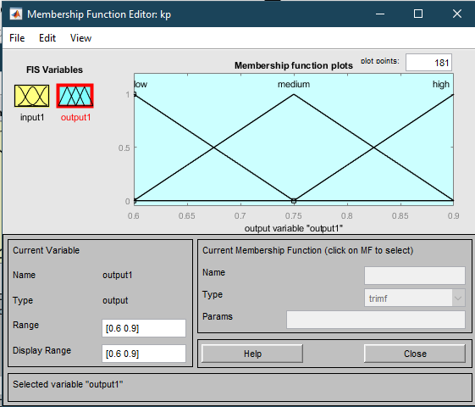**Figure 3.1: Kp Input**

**Figure 3.2: Kp output**

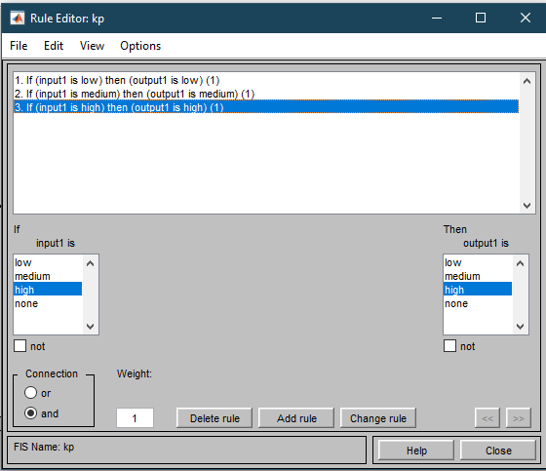

**Figure 3.3: Kp rules**

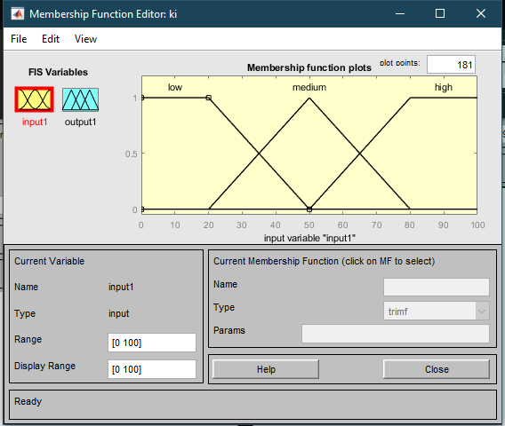

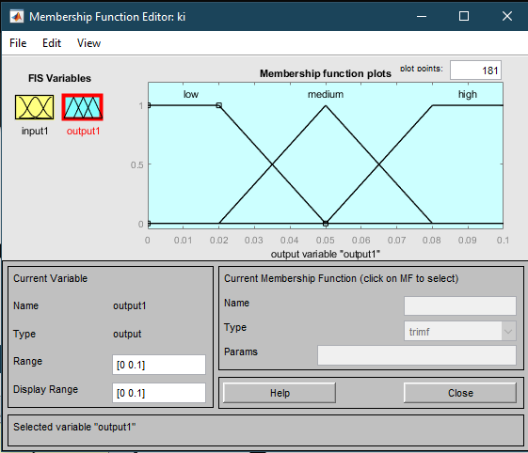**Figure 3.4: Ki input**

**Figure 3.5: Ki output**

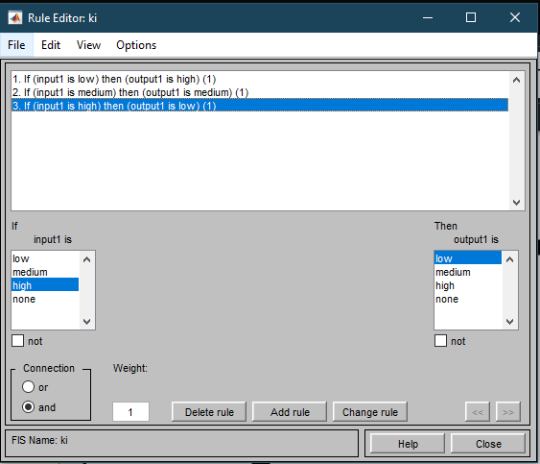

**Figure 3.6: Ki Rules**

1. 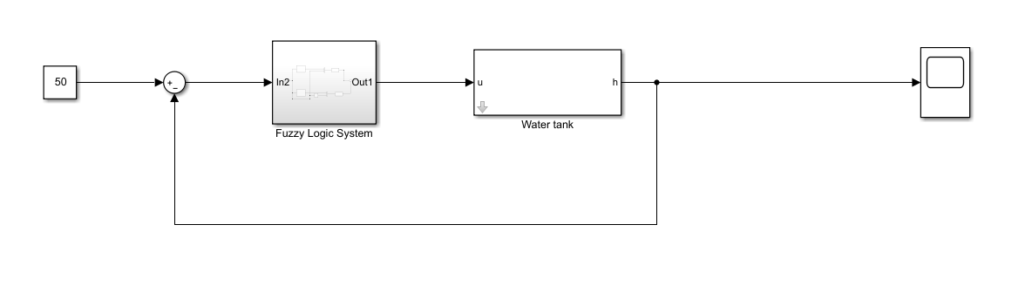**Matlab Simulink**

**Figure 3.7: Fuzzy Logic System Blocks**

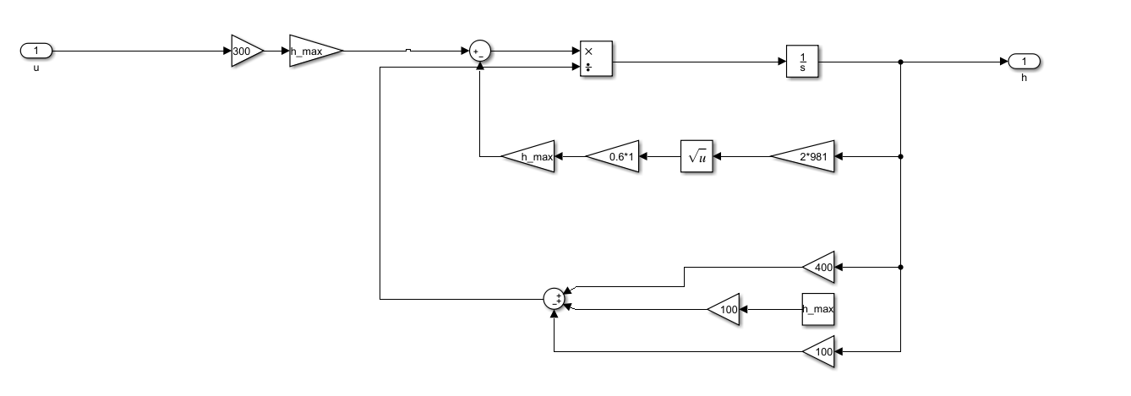**Figure 3.8: Water Tank Block**

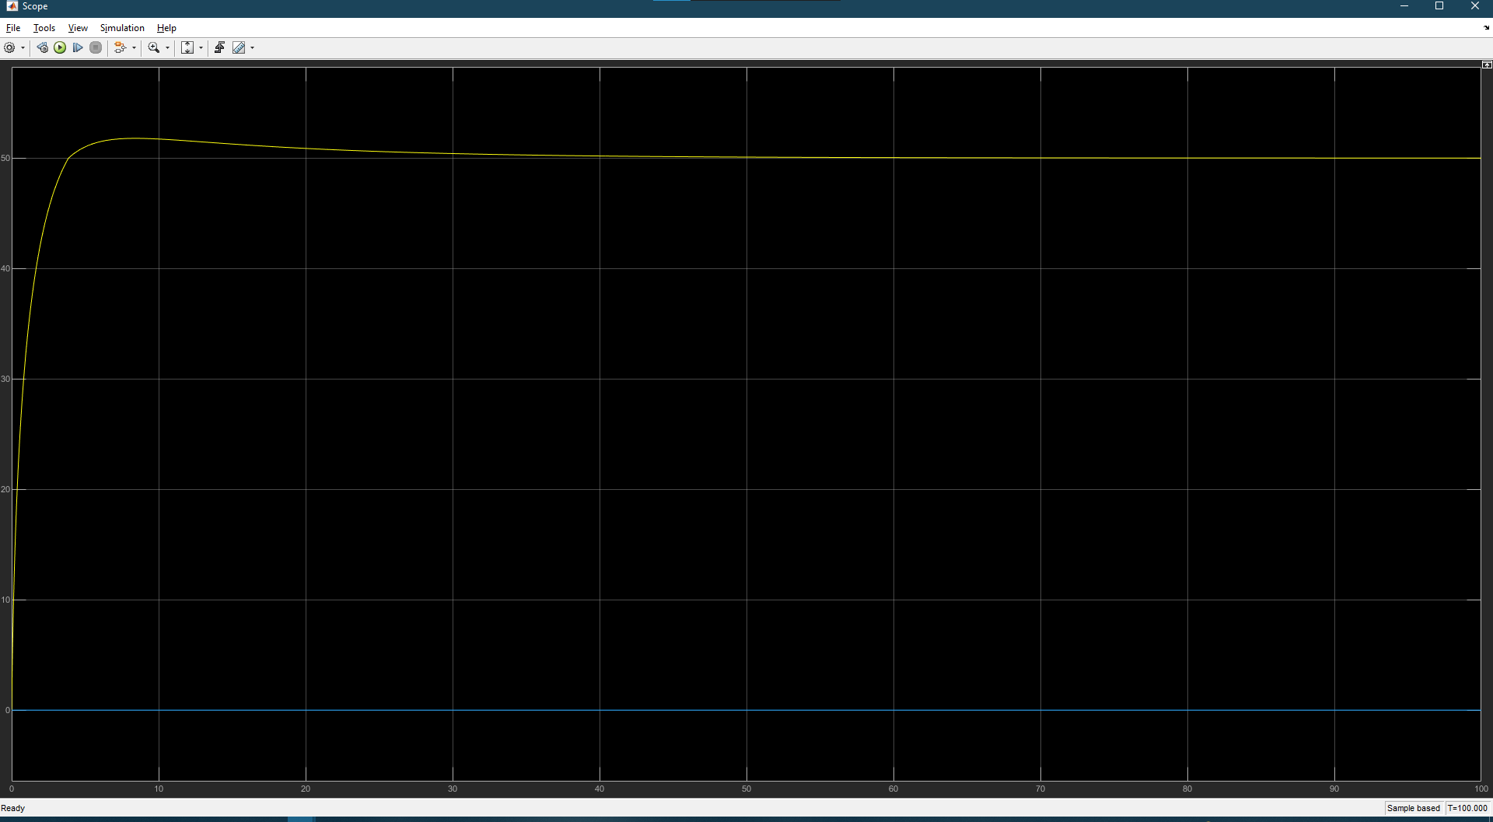**Result:**

**Figure 3.9: Result of Fuzzy Control System**

1. **Neural Network System**
2. **Building A Neural Network System**

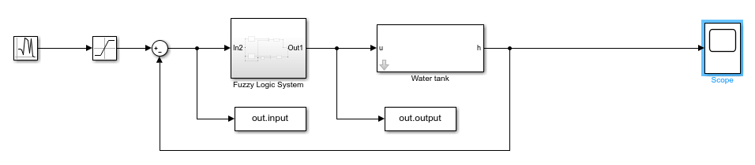First, the neural network system needs various input/output values. Therefore, the input and output of the fuzzy logic system is be collected by random number input.

**Figure 3.10: Collected input and output of the fuzzy system**

Once we have the data of input and output, we can use nntool in Matlab to build our network.

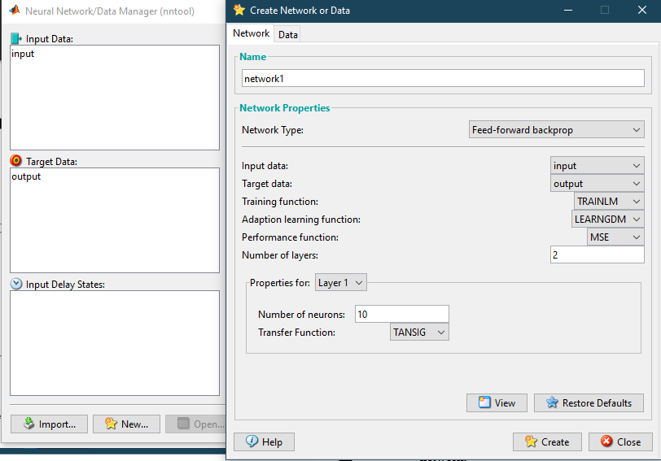

**Figure 3.11: Using nntool to build neural network**

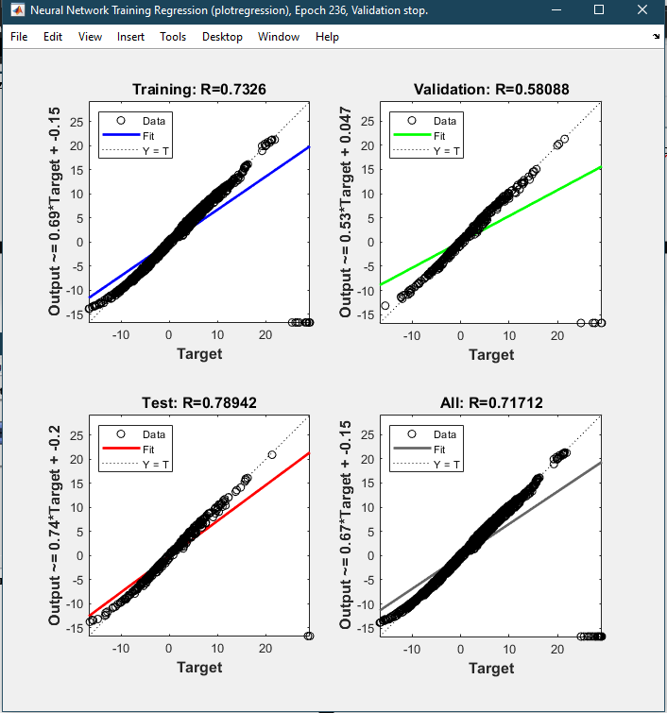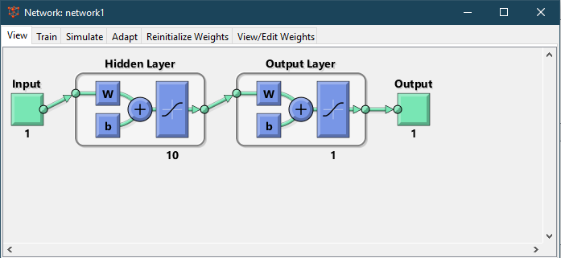**Figure 3.12: Neural network model**

**Figure 3.13: Regression Plot (Before setting weights)**

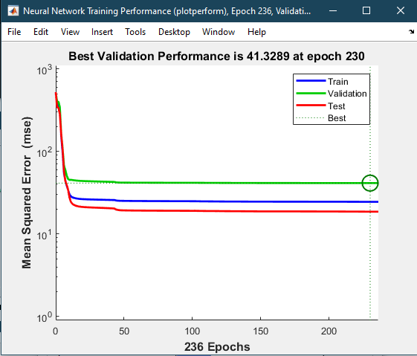

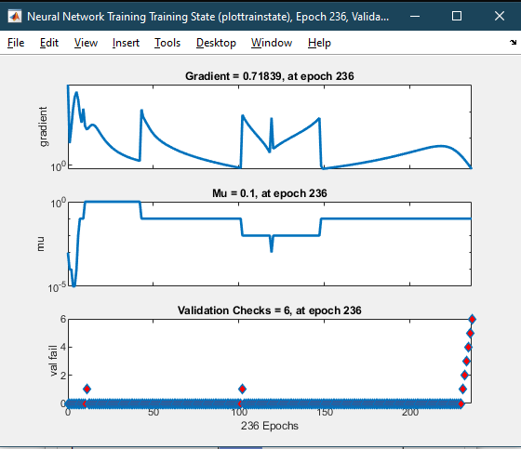**Figure 3.14: Performance plot(Before setting weights)**

**Figure 3.15: Training state plot(Before setting weights)**

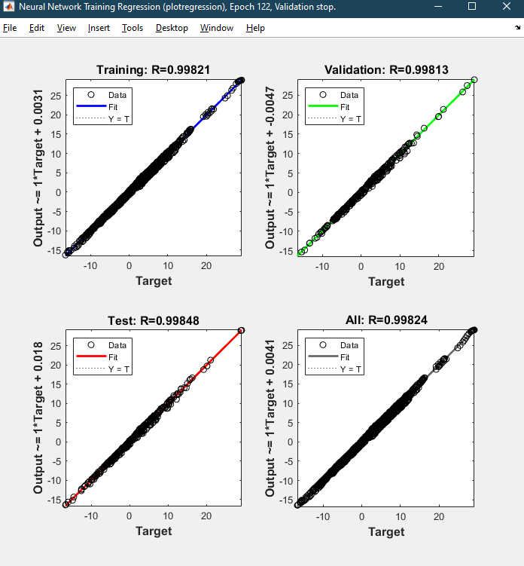

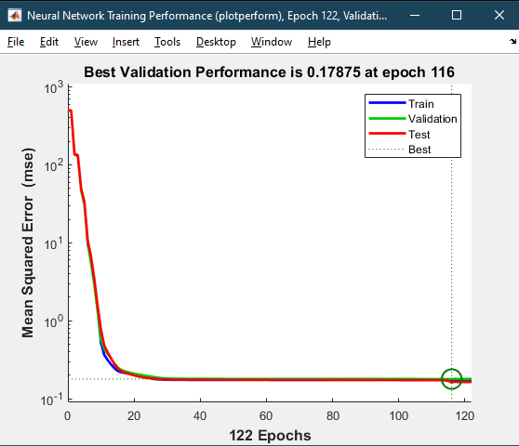**Figure 3.16: Regression Plot (After setting weights)**

**Figure 3.17: Performance Plot (After setting weights)**

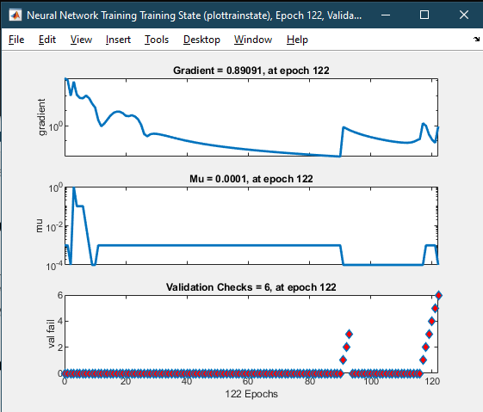

**Figure 3.18: Training State Plot (After setting weights)**

1. 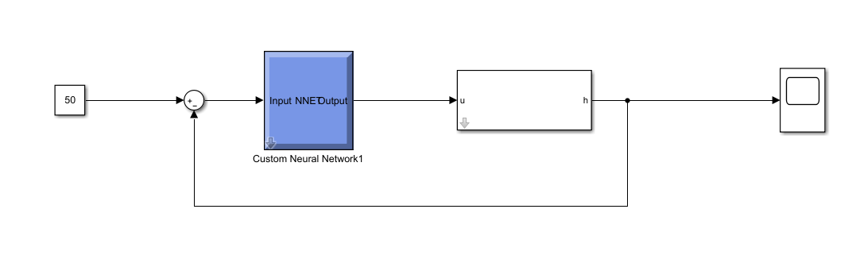**Matlab Simulink**

**Figure 3.19: Neural Network Block**

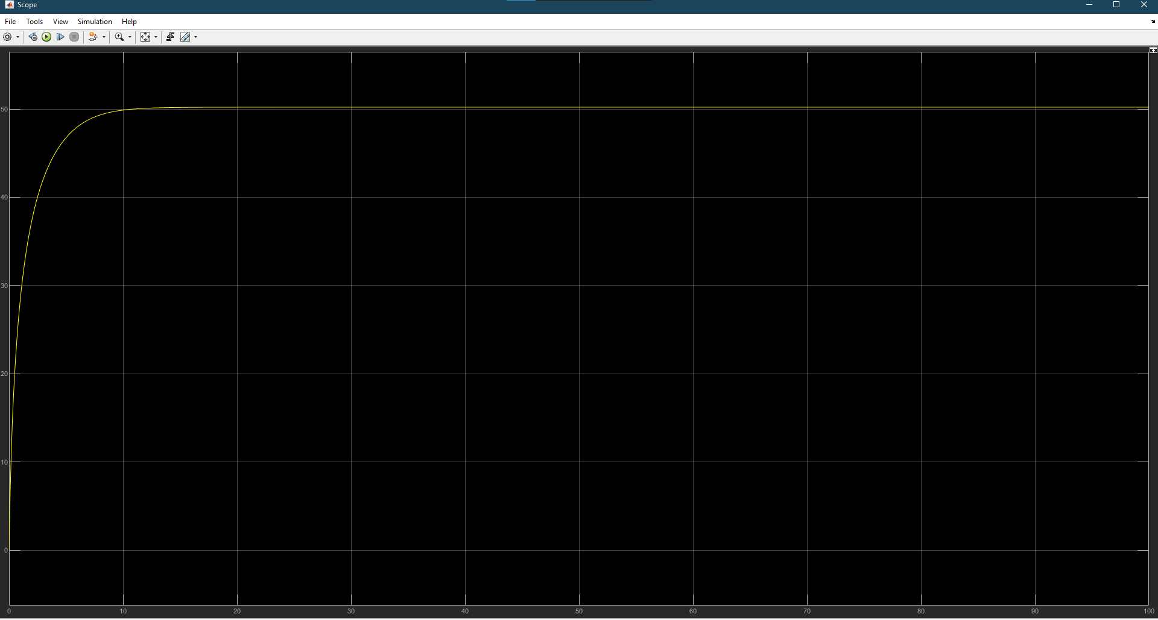**Result:**

**Figure 3.20: Result of Neural network**

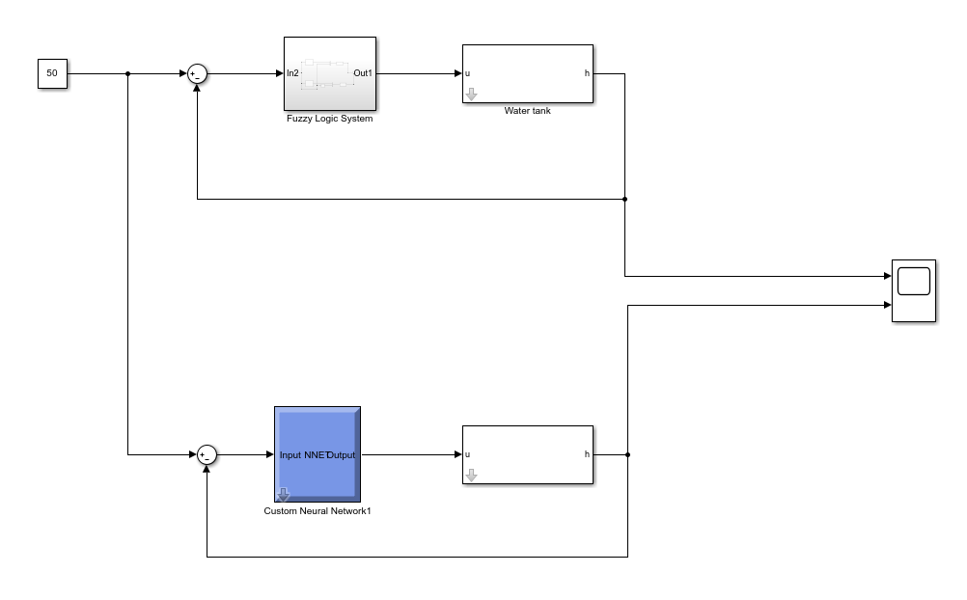**FINAL RESULT SIMULINK BLOCK:**

**Figure 3.21: Final Block**

# **CHAPTER IV**

# **CONCLUSION**

1. **Conclusion**

The project has designed the fuzzy logic control and neural network control for the water level control system. However, the rising time isn’t the best option because of it has the perfect plot, which is only appears in paper. Therefore, the project need to be checked again before building protocol for it.

# **References**

[1]: [Fuzzy Logic | Introduction - GeeksforGeeks](https://www.geeksforgeeks.org/fuzzy-logic-introduction/)

[2]: [What are Neural Networks? | IBM](https://www.ibm.com/topics/neural-networks)

[3] DESIGN OF WATER LEVEL CONTROLLER USING FUZZY LOGIC SYSTEM – Mr.Harshdeep Singh

[4]: [5.3. Forward Propagation, Backward Propagation, and Computational Graphs — Dive into Deep Learning 1.0.3 documentation (d2l.ai)](https://d2l.ai/chapter_multilayer-perceptrons/backprop.html)